Haley Anderson & Sarah Lasman

CPSC 408 -- Database Management

Professors German & Linstead

14 December 2018

Simplifying the Job Search

At some point in their life, everyone has had to face the stress and uncertainty that is finding a job. While the job search is a necessary part of growing up and finding your own space in the world, for many people it can cause large amounts of anxiety and stress. *Did I pick the right job? Was there a better one I just hadn’t seen yet? Do I want to move there?* These are all questions that can plague the mind of the job search-er and the newly employed alike. While it is hard to ever quantity if the decision you make is the “right” decision, it never hurts to be more informed of the options in order to make the most educated decision possible. With our database, we aim to help the job searcher have a more streamlined and and less anxiety-inducing experience while looking for their perfect fit. With an application that can be easily used by both potential employers adding jobs and potential employees searching for jobs, this it the job search simplified.

There are an overwhelming amount of job options across the world. Some of the struggles that one would face while job searching is narrowing the mass amounts of job postings by relevant data points. Narrowing the field by job location, the industry, or pay would help to bring the amount of job options down to a reasonable amount. Being able to narrow on these qualities would also help companies find employees that are happier with the situation. Additionally, with the specific information required to add a job to the job board, a potential employee can have a better idea of the job and company they are applying for, helping to eliminate applicants that are unqualified or apply in error. An employee that is settling for a job and is unhappy in their position does not benefit the company or the employee. Our solution was to implement a job search database, accessible to both employers and prospective employees. Although such applications already exist in basic form, we hoped to make ours more student-focused by providing specific guidelines that allow people to search specifically for internships, as well as searching for full time jobs for post-graduation. We also wanted to be able to provide statistics about the jobs in our database, so that people know more information about the market they are headed into. We also added an option to add managers to a company so that applicants can get a better idea of the type of person that works at a specific company, as well as the length of time they have worked at that company for, and could potentially contact a manager directly for more information about the company. One of the most important aspects of the manager is the length of time they have worked at the company for. If a number of managers have been at the company for a significant amount of time, this could indicate that employees generally enjoy working for this company because they have stayed for so long. But, this also means that there are potentially limited opportunities for rapid advancement through the corporate ladder of that company. With this information, an applicant can decide whether this would be a positive or negative aspect of a company. The more information that the applicant can find about the job, and the company that this job is in, the more sure they can be about their decision to apply or pass.

The database we created can be accessed via a command-line interface or a graphical user interface, GUI, depending on the user’s preference. We implemented the command-line interface first, for purposes of presentation while the GUI was still being built. Originally we had planned to delete it when we finished the GUI, but its functionality was sophisticated enough that we left it in the final product. Each format is better suited for different ways of using the database; the GUI is more user-friendly when it comes to adding and searching for jobs, while the command-line interface allows for users to see past transactions and statistics easier. Thus, we added the option to use either interface.

Currently, any user of the database can search for, add, update, or delete a job, although were we to market this database, we would ensure that only verified users could add, update, or delete information on behalf of their company. There is also an option to add managers to a company, and show the managers that work in a company. Additionally, any user can see the entire job database or search for select info, or find jobs that meet their location, type, or industry preferences. The database can write out to CSV files upon request, and will also do so upon exiting the database to ensure that changes are saved. There is an array of statistics that can be found using the database. In the “statistics” option, as well as in each of the search options, several statistics are shown to the user. These statistics include the number of summer internships, the number of unpaid internships, the number of companies in a specific region, and the average salary of full time jobs or rates of internships, and many more.

We implemented this design using a schema of eight tables. The “base” table that the rest of the tables generally spin off from is the Job table. The Company table is used to store more information on the company that is represented in the Job table through the “companyId” field, such as the “company name” and the company’s “yearly revenue.” The Company table also connects to the Manager table through the “companyId” field. Aspects of this table were discussed earlier. The Location table stems from the Company table and gives more information on the physical location of the company such as the “location area” (region) and the mailing address, and is represented through the “companyId” field. The Internship and Full Time tables are stemmed from the “isInternship” field in the Job table. For a certain job, if the “isInternship” field is true a corresponding record is added to the Internship table, connected through the “jobId” field. The Internship table stores information on the “season” of the internship and its “pay period”, monthly versus hourly and etcetera. If the “isInternship” field is false, the corresponding record is added to the Full Time table, which informs the applicant of the “salary” and “signing bonus” that is associated with the job. The Competition table provides more information on the application aspect of the job, with fields such as “number of applicants” and “number of open spots.” This table is a required entry connected through the “jobId” field. The Related Jobs table is an optional table that is connected to the Job table through the “jobId” field. The Related Jobs table stores the Id numbers of up to five jobs that are related to the primary job. The full schema is shown below.

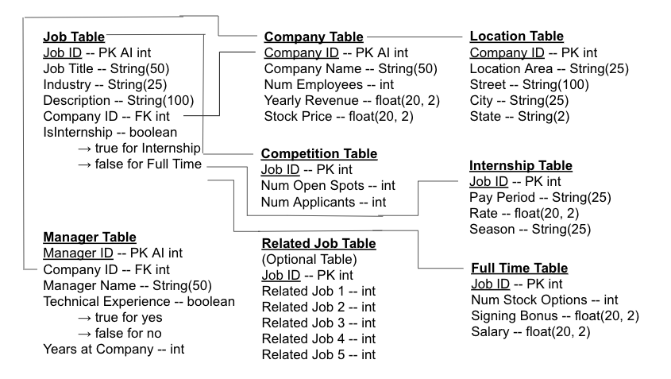

In conclusion, we have created a database and application that will help streamline and simplify the job application process by helping employers get their job opportunities seen by potential applicants and helping applicants gather as much information as possible about a job in order to make a well informed decision on whether to apply or not. Through our database implementation and the interface, either command-line or GUI, we have accomplished our vision and helped to create an environment that fosters happy employers and employees.